**ASSIGNMENT - 3**

Name : B . Naveen Kumar

Course Name : Python AI and ML

Course Tutor : Harshee Pitroda

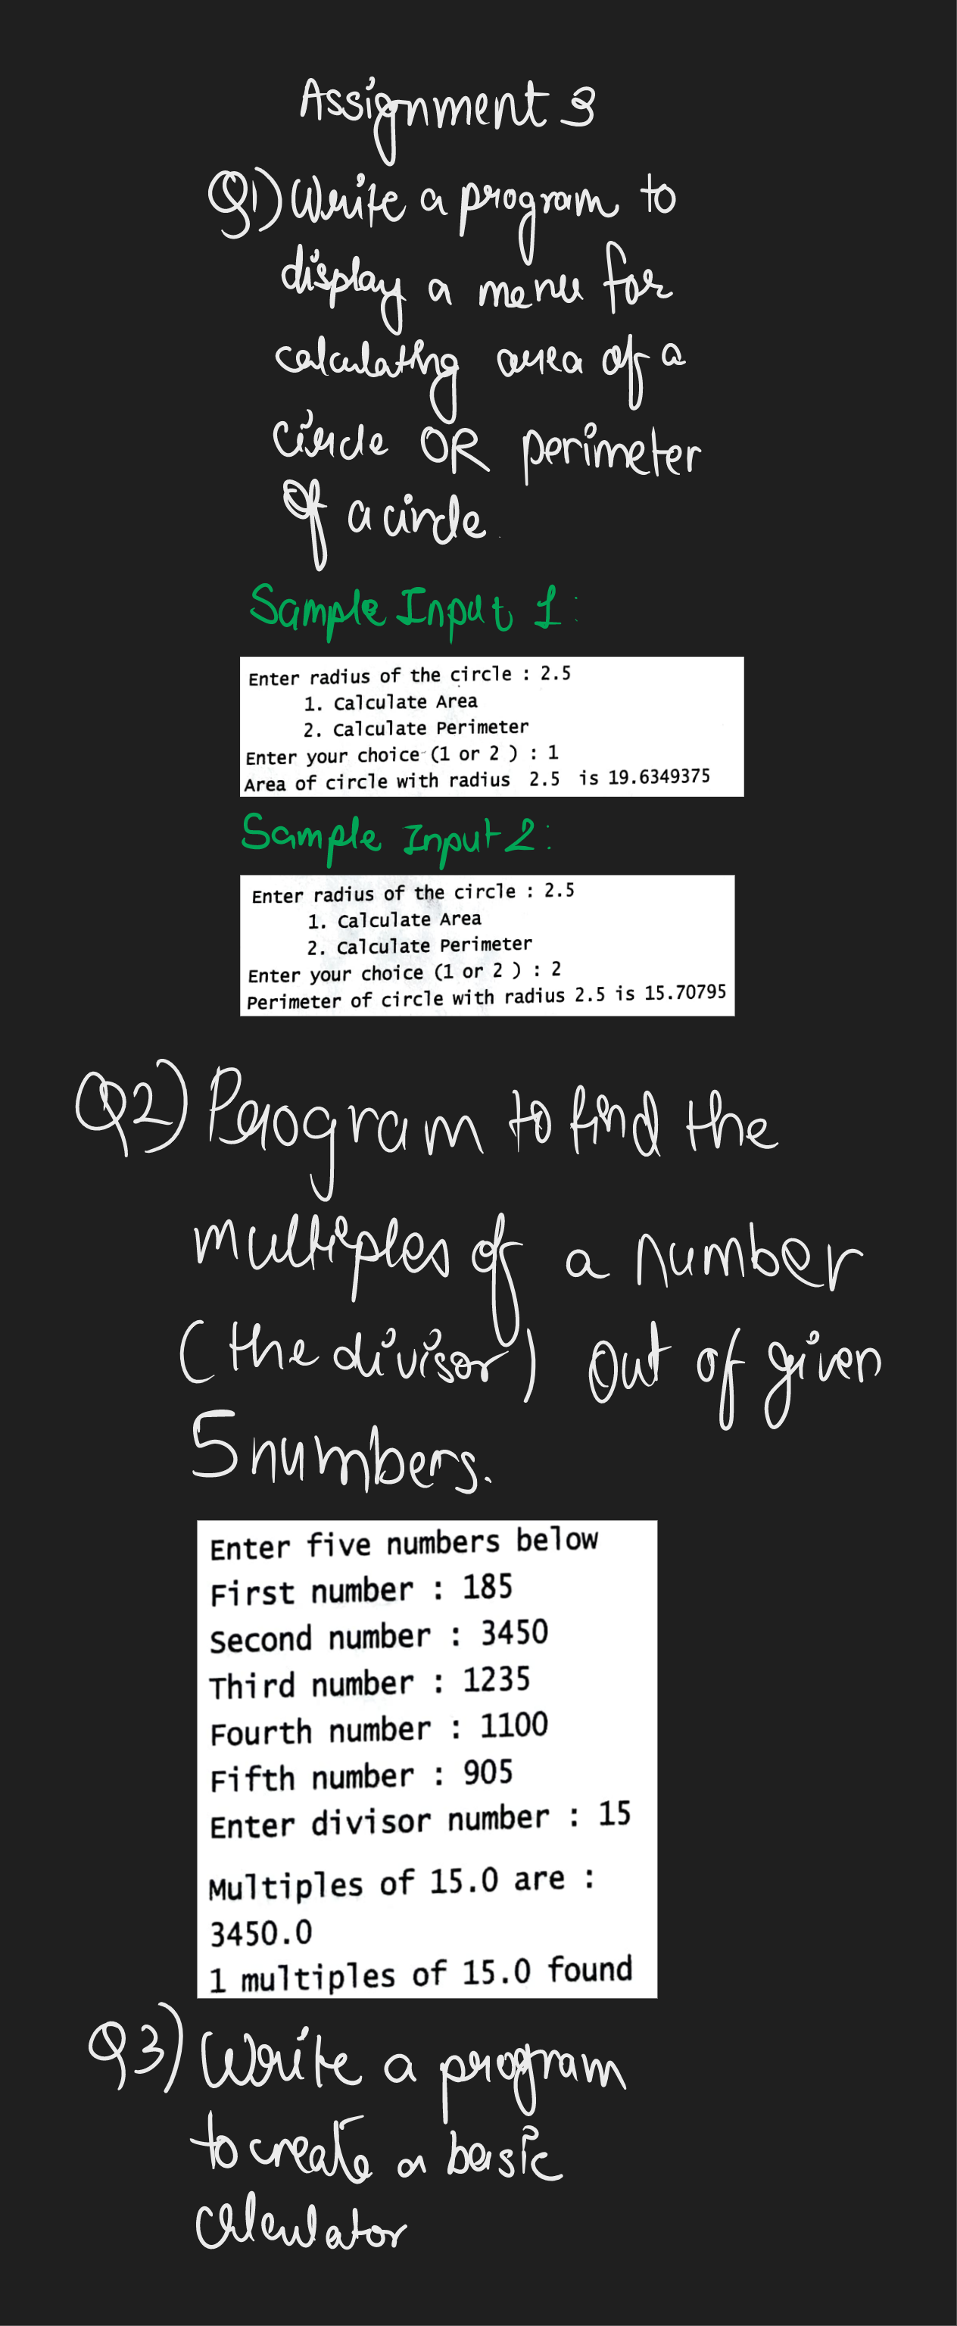

Q1.

from math import pi

n=float(input('Enter the radius of the circle : '))

print(f'{1:6.0f}. Calculate Area\n{2:6.0f}. Calculate Perimeter')

x=int(input("Enter your choice (1 or 2) : "))

if x==1:

    print(f'Area of the circle with radius {n} is {pi*pow(n,2):.7f}')

elif x==2:

    print(f'Perimeter of the circle with radius {n} is {2*pi*n:.5f}')

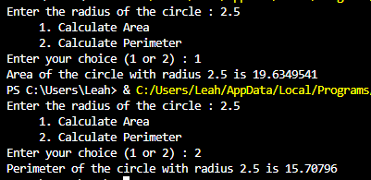

Q2.

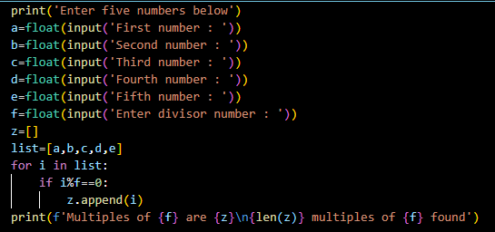

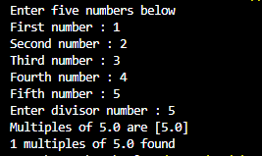

Q3.

